Introduction to Algorithms- Day 02

Time Complexity Examples: -

- For(i=1;i<n; i=i*2)
{
Stmt;
}

In this case,
Initally i=1, then its multiplied by 2 for each iteration until i>=n//
So,
i= 1*2*2……=n
2^k=n
Time complexity=K=log ₂n= [logn]//
Its denoted as ceil value to avoid the fraction//

- For(i=1;i<=n;i++)
{
Stmt;
}

For this case,

Initally, i=1 and then it goes on incrementing by 1 until i>=n

So,

i= 1+1+1+1+……. +1=n

time complexity=k=n//

- For( i=1;i>=1;i=i/2)
{
Stmt;
}

In this case,

It starts from i/n.. n/2..n/2^2…n/2^3….. n/2^k

It executes until,

Assume i<1,

Therefore, n/2^k<1

n/2^k=1

n= 2^k

k= log₂n//

time complexity= O(logn)//

- For(i=0;i*i<n;i++)
{
Stmt;
}

In this case,

I*i<n

It will execute until,

I*i>=n

By Equating we get,

I^2=n
I=$\sqrt{\left\{n\right\}}$//

For (i=0; i<n; i++)
{
Stmt; -------------------------- n
}
For (j=0; j<n; j++)
{
Stmt; -------------------------n
}

Total Time= 2n//

For independent loops, the loops go till n only and hence the time complexity is O(n)//

- P=0
For(i=1;i<n;i=i*2)
{
P++;-------------------------------- p=log n
}

For(j=1;j<p;j=j*2)
{
Stmt; -------------------------------- log p
}

Time complexity= O (log logn)//

Note:- Since we have i=i*2 it directly evaluates to log n as seen previously//

- For(i=0;i<n:i++)--------------------------- n
{
For(j=1;j<n;j=j*2)-------------------------n * log n
{
Stmt;--------------------------------------n* log n
}
}

Total = 2nlogn +n
Time Complexity= O(n log n)//

Time complexity of majority of examples until now:-

- For(i=0;i<n;i++)-------------------------- O(n)//
- For(i=0;i<n;i=i+2) ----------------------- n/2= O(n)//
- For(i=n;i>1;i--) ----------------------------- O(n)//
- For(i=1;i<n;i=i*2) ------------------------- O(log₂n)//
- For(i=1;i<n;i=i*3) -------------------------- O(log₃n)//
- For(i=n;i>1;i=i/2) -------------------------- O(log₂n)//

Time Complexity Analysis of If and While Loops

1)
i=0--------------------- 1
while(i<n)------------ N+1
{
Stmt; --------------- n
I++; ----------------- n
}
Total time= 3n+2
F(n) =3n+2
= O(n)//

2)
A=1;
While(a<b)
{
Stmt;
a=a*2;
}

Analysis:-
A
1
1*2=2
2*2=2^2
2^2*2=2^3
:
:
:
2^k
Now, the loop will terminate when a>=b
a>=b
therefore, a=2^k
2^k >=b
2^k=b
K=log₂b
Time complexity= O (log n)//

3)
I=n
While(i>1)
{
Stmt;
I=i/2;
}
Time complexity= O (log n)//
As mentioned, wherever we have i=i/2 or i=i*2 we can directly interpret it as O (log n)//

4)
i=1
k=1
while(k<n)
{
Stmt;
K=k+i;
I++;
}
For this case, lets analyze,
i | k
1 | 1
2 | 1=1=2
3 | 2+2=4
4 | 2+2+3=7
5 | 2+2+3+4=11
.. | ..
m | m(m+1)/2 (sum of first m natural numbers)//

Lets assume it will execute until k>=n,
m(m+1)/2>=n
m^2>=n
m=$\sqrt{\left\{n\right\}}$ //

5) GCD of 2 Numbers m and n analysis:-
While (m! =n)
{
If(m>n)
{
m=m-n;
}
Else
{
N=n-m;
}

Lets analyze the algorithm,
For the above example:-
It will execute until m=n that means m!=n,
Case I:-
When m=4 n=2
Iteration 01: m=2 and n=2 (executes only once)
When m=2 n=2
Both are equal only so it will execute 0 times//
When m=16 and n=2m it will execute 7 times ,i.e almost (n/2) times//
Time complexity= O(n/2)= O(n) (degree of the polynomial) (Worst Case)//
Minimum time complexity= O (1) (Best Case)//

6)
Random example with if:-
Algorithm Test(n)
{
If(n<5)
{
Printf(“%d”,n) ------------------- 1 --- O(1)---(if its True) (Best Case)
}
Else
{
For(i=0;i<n;i++)
{
Printf(“%d”,i) -----------------------n--- O(n)--- (if its False) (Worst Case)
}
}
}
If a loop is using conditional statement, the time complexity varies depending upon the condition that is being utilized for the execution//
Its not a rule that if the conditional statement is there then best case will always be O(1) like in the example below:-
Algorithm Test(n)
{
If(n<5)
{
For(i=0;i<n;i++)
{
Printf(“%d”,i) ---------------------- n = O(n)= (Best Case)//
}
}
}

For conditional statements within loops the outputs will vary depending upon the condition//
Types (Classes) of Time Functions: -
- O(1)----------------------- Constant
Example:-
F(n)=2, f(n)=5, f(n)=5000= O(1)//
- O(log n)------------------- Logarithmic
- O(n)------------------------ Linear
Example: -

F(n)=2n+3, f(n)=500n+700, f(n)=n/5000 + 6= O(n)//

- O(n^2)-------------------- Quadratic

- O(n^3)--------------------- Cubic

- O(2^n), O(3^n), O(n^n) -------------------- Exponential

---------------------------------------------- Compare Class of Time Functions -----------------------------------------

1<log n<$\sqrt{\left\{n\right\}}$<n<n logn<n^2<n^3<…………………. <2^n<3^n<……………. <n^n<n!//

Example:-
log n | N | N^2 | 2^n
0 | 1 | 1 | 2
1 | 2 | 4 | 4
2 | 4 | 16 | 16
3 | 8 | 64 | 256
3.1 | 9 | 81 | 512
 | 15 | 225 | 32,768

So, you can see how the growth is 2^n grows very fast hence exponential then n^2 hence quadratic then N hence linear and then log n and hence logarithmic//

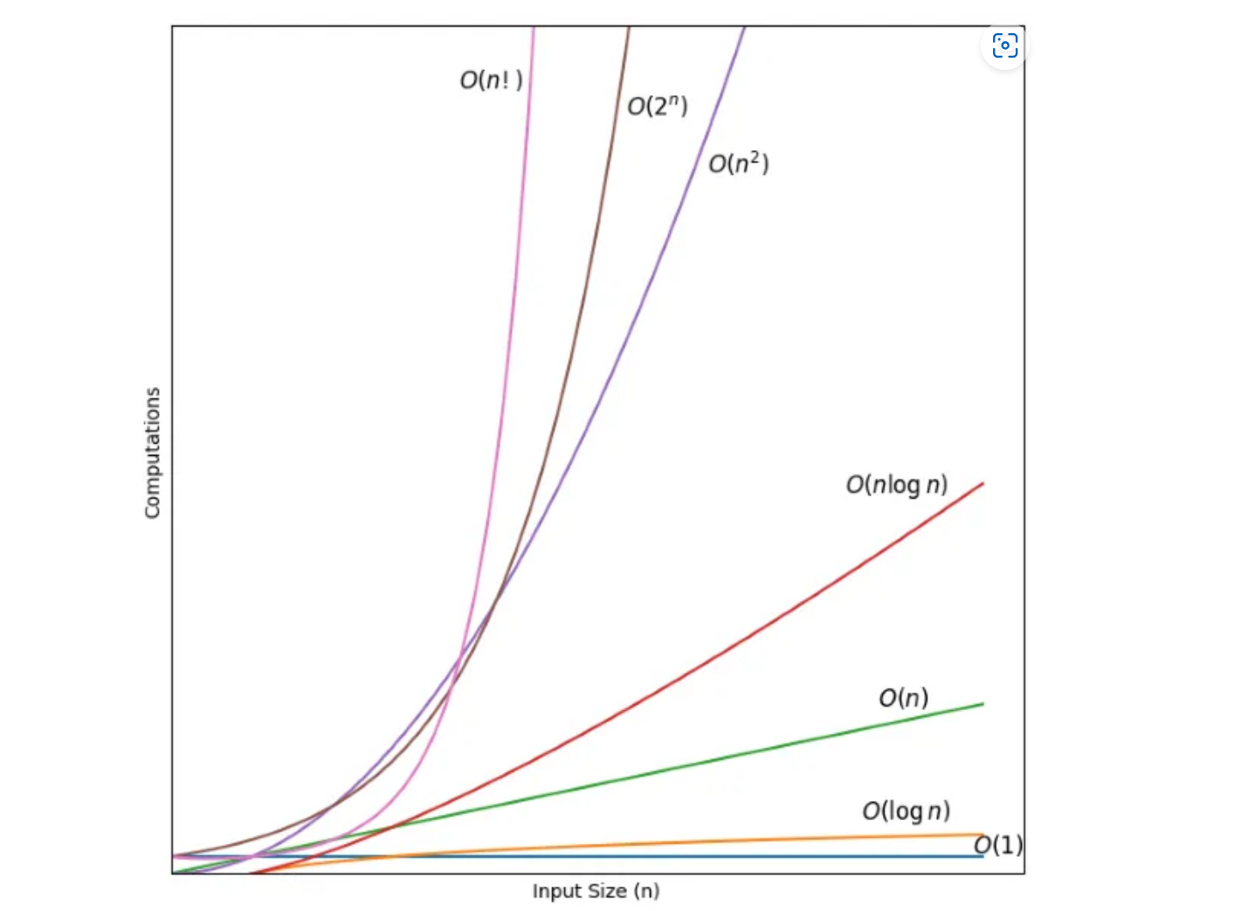
Fig:- Comparison of various time Functions/Classes

We did not mention about n! it has the highest growth,
O(n!) — Factorial Time
Time complexity= O(n!)//

